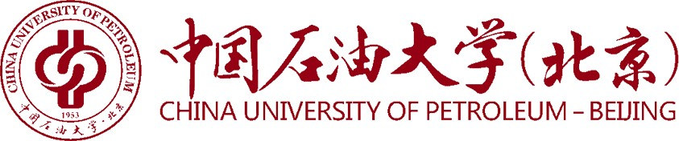

Certificate of Graduation

June 21, 2023
This is to certify that Mr./Ms. Zhang San, born on May. 03, 1998, has studied at China University of Petroleum-Beijing at Karamay, as a four-year fulltime undergraduate on the program of Chemical Engineering and Technology from September 2019 to June 2023. Upon completing and passing all the required courses of the program, he/she is hereby awarded this certificate of graduation.
Certificate No.114141202305200000

President
